Filed by Zoom Video Communications, Inc.

Pursuant to Rule 425

under the Securities Act of 1933, as amended

and deemed filed pursuant to Rule 14d-2

under the Securities Exchange Act of 1934, as amended

Subject Company: Five9, Inc.

(Commission File No. 001-36383)

The following communications are being filed in connection with the acquisition of Five9, Inc. (“Five9”) by Zoom Video Communications, Inc.

(“Zoom”):

Investor Presentation




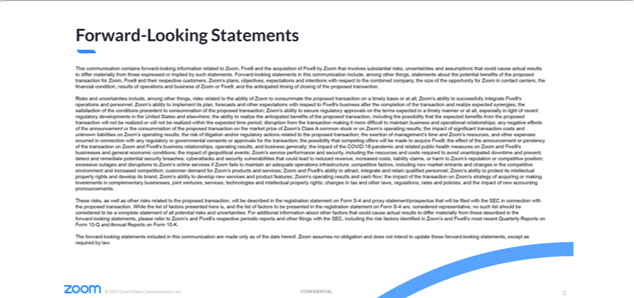

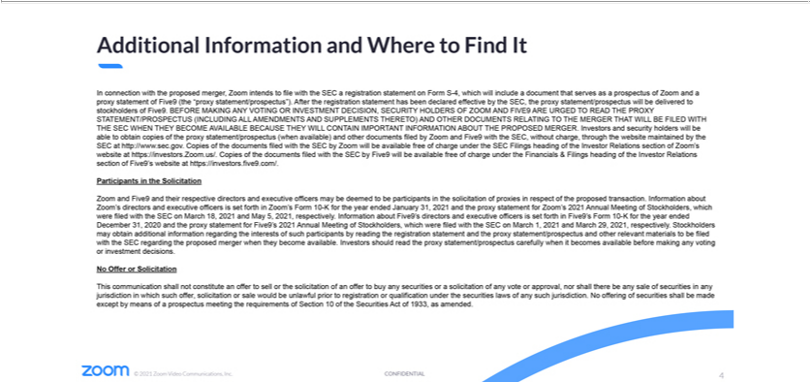

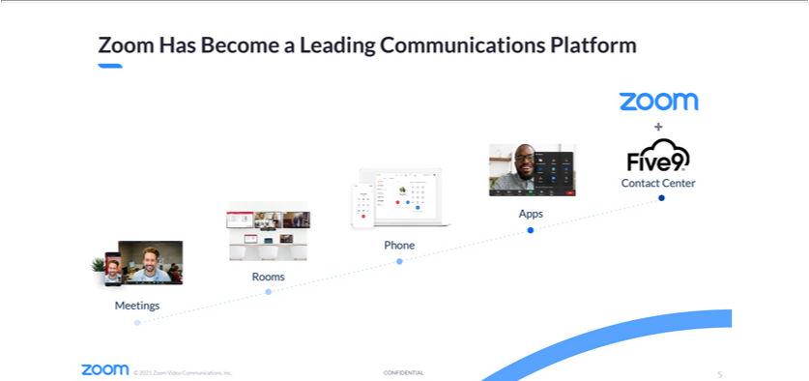

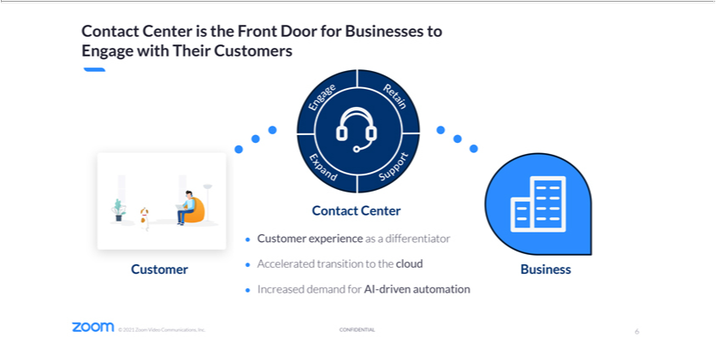

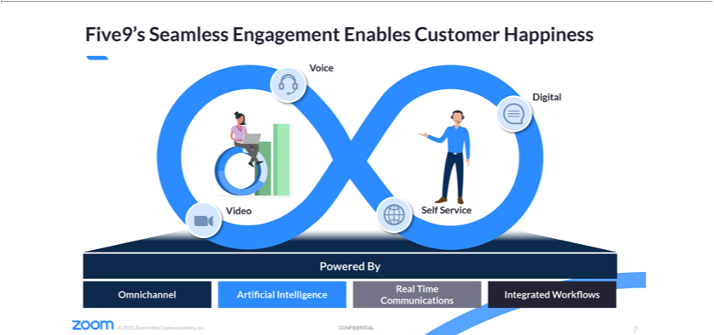

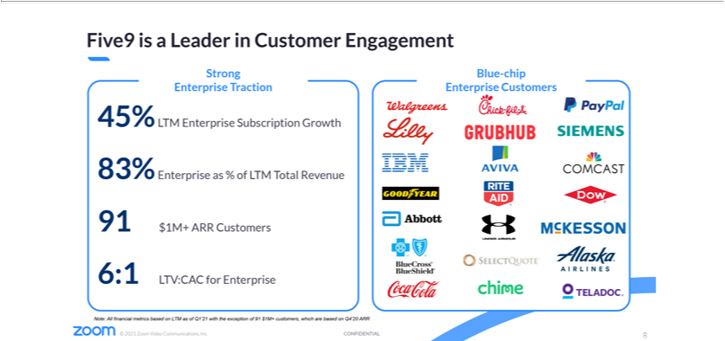

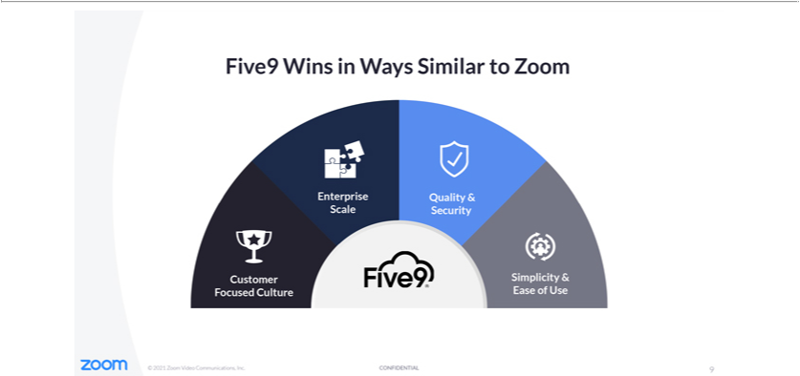

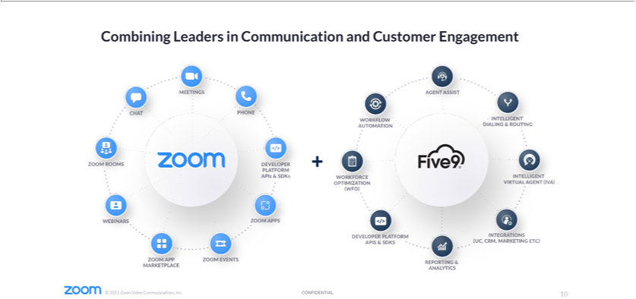

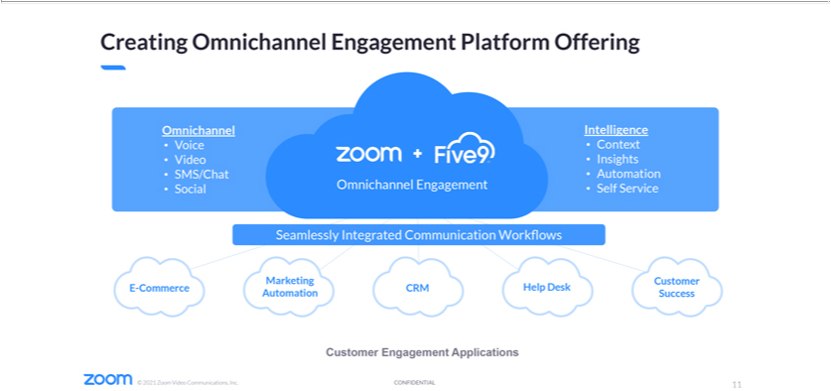

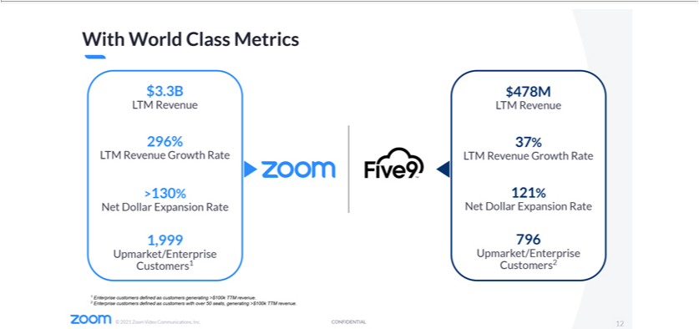

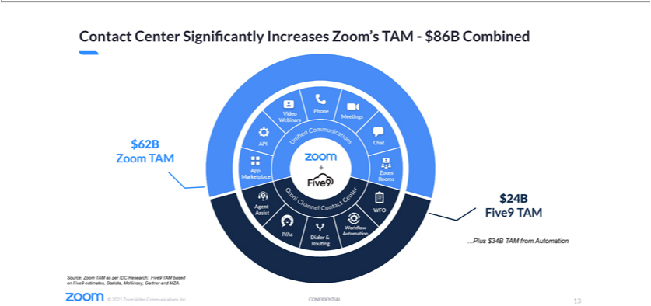

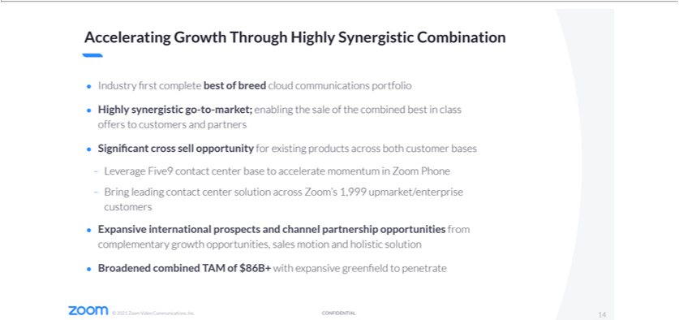

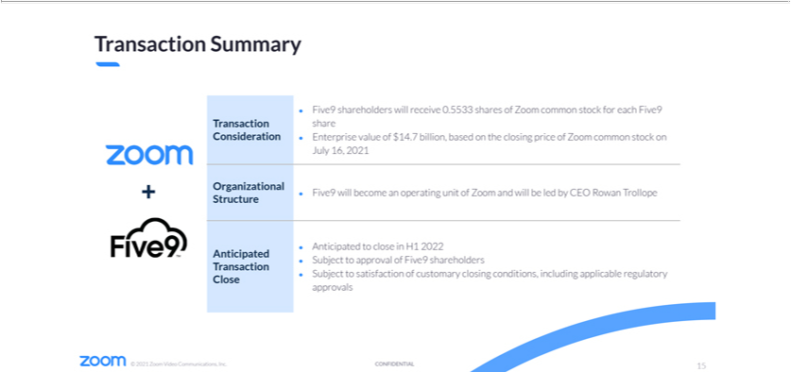

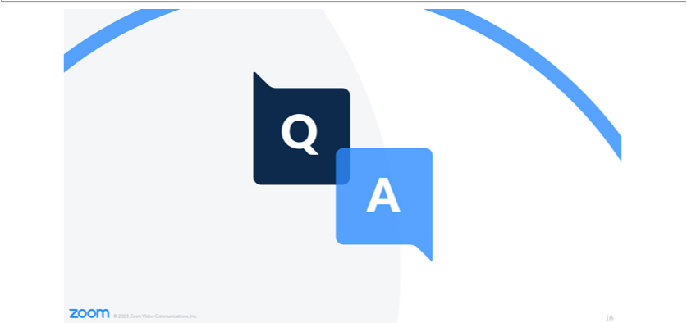



Forward-Looking Statements

This communication contains forward-looking information related to Zoom, Five9 and the acquisition of Five9 by Zoom that involves substantial risks, uncertainties and assumptions that could cause actual results to differ materially from those expressed or implied by such statements. Forward-looking statements in this communication include, among other things, statements about the potential benefits of the proposed transaction for Zoom, Five9 and their respective customers, Zoom’s plans, objectives, expectations and intentions with respect to the combined company, the size of the opportunity for Zoom in contact centers, the financial condition, results of operations and business of Zoom or Five9, and the anticipated timing of closing of the proposed transaction.

Risks and uncertainties include, among other things, risks related to the ability of Zoom to consummate the proposed transaction on a timely basis or at all; Zoom’s ability to successfully integrate Five9’s operations and personnel; Zoom’s ability to implement its plan, forecasts and other expectations with respect to Five9’s business after the completion of the transaction and realize expected synergies; the satisfaction of the conditions precedent to consummation of the proposed transaction; Zoom’s ability to secure regulatory approvals on the terms expected in a timely manner or at all, especially in light of recent regulatory developments in the United States and elsewhere; the ability to realize the anticipated benefits of the proposed transaction, including the possibility that the expected benefits from the proposed transaction will not be realized or will not be realized within the expected time period; disruption from the transaction making it more difficult to maintain business and operational relationships; any negative effects of the announcement or the consummation of the proposed transaction on the market price of Zoom’s Class A common stock or on Zoom’s operating results; the impact of significant transaction costs and unknown liabilities on Zoom’s operating results; the risk of litigation and/or regulatory actions related to the proposed transaction; the exertion of management’s time and Zoom’s resources, and other expenses incurred in connection with any regulatory or governmental consents or approvals for the transaction; the possibility that competing offers will be made to acquire Five9; the effect of the announcement or pendency of the transaction on Zoom and Five9’s business relationships, operating results, and business generally; the impact of the COVID-19 pandemic and related public health measures on Zoom and Five9’s businesses and general economic conditions; the impact of geopolitical events; Zoom’s service performance and security, including the resources and costs required to avoid unanticipated downtime and prevent, detect and remediate potential security breaches; cyberattacks and security vulnerabilities that could lead to reduced revenue, increased costs, liability claims, or harm to Zoom’s reputation or competitive position; excessive outages and disruptions to Zoom’s online services if Zoom fails to maintain an adequate operations infrastructure; competitive factors, including new market entrants and changes in the competitive environment and increased competition; customer demand for Zoom’s products and services; Zoom and Five9’s ability to attract, integrate and retain qualified personnel; Zoom’s ability to protect its intellectual property rights and develop its brand; Zoom’s ability to develop new services and product features; Zoom’s operating results and cash flow; the impact of the transaction on Zoom’s strategy of acquiring or making investments in complementary businesses, joint ventures, services, technologies and intellectual property rights; changes in tax and other laws, regulations, rates and policies; and the impact of new accounting pronouncements.

These risks, as well as other risks related to the proposed transaction, will be described in the registration statement on Form S-4 and proxy statement/prospectus that will be filed with the SEC in connection with the proposed transaction. While the list of factors presented here is, and the list of factors to be presented in the registration statement on Form S-4 are, considered representative, no such list should be considered to be a complete statement of all potential risks and uncertainties. For additional information about other factors that could cause actual results to differ materially from those described in the forward-looking statements, please refer to Zoom’s and Five9’s respective periodic reports and other filings with the SEC, including the risk factors identified in Zoom’s and Five9’s most recent Quarterly Reports on Form 10-Q and Annual Reports on Form 10-K.

The forward-looking statements included in this communication are made only as of the date hereof. Zoom assumes no obligation and does not intend to update these forward-looking statements, except as required by law.

Additional Information and Where to Find It

In connection with the proposed merger, Zoom intends to file with the SEC a registration statement on Form S-4, which will include a document that serves as a prospectus of Zoom and a proxy statement of Five9 (the “proxy statement/prospectus”). After the registration statement has been declared effective by the SEC, the proxy statement/prospectus will be delivered to stockholders of Five9. BEFORE MAKING ANY VOTING OR INVESTMENT DECISION, SECURITY HOLDERS OF ZOOM AND FIVE9 ARE URGED TO READ THE PROXY STATEMENT/PROSPECTUS (INCLUDING ALL AMENDMENTS AND SUPPLEMENTS THERETO) AND OTHER DOCUMENTS RELATING TO THE MERGER THAT WILL BE FILED WITH THE SEC WHEN THEY BECOME AVAILABLE BECAUSE THEY WILL CONTAIN IMPORTANT INFORMATION ABOUT THE PROPOSED MERGER. Investors and security holders will be able to obtain copies of the proxy statement/prospectus (when available) and other documents filed by Zoom and Five9 with the SEC, without charge, through the website maintained by the SEC at http://www.sec.gov. Copies of the documents filed with the SEC by Zoom will be available free of charge under the SEC Filings heading of the Investor Relations section of Zoom’s website at https://investors.Zoom.us/. Copies of the documents filed with the SEC by Five9 will be available free of charge under the Financials & Filings heading of the Investor Relations section of Five9’s website at https://investors.Five9.com/.

Participants in the Solicitation

Zoom and Five9 and their respective directors and executive officers may be deemed to be participants in the solicitation of proxies in respect of the proposed transaction. Information about Zoom’s directors and executive officers is set forth in Zoom’s Form 10-K for the year ended January 31, 2021 and the proxy statement for Zoom’s 2021 Annual Meeting of Stockholders, which were filed with the SEC on March 18, 2021 and May 5, 2021, respectively. Information about Five9’s directors and executive officers is set forth in Five9’s Form 10-K for the year ended December 31, 2020 and the proxy statement for Five9’s 2021 Annual Meeting of Stockholders, which were filed with the SEC on March 1, 2021 and March 29, 2021, respectively. Stockholders may obtain additional information regarding the interests of such participants by reading the registration statement and the proxy statement/prospectus and other relevant materials to be filed with the SEC regarding the proposed merger when they become available. Investors should read the proxy statement/prospectus carefully when it becomes available before making any voting or investment decisions.

No Offer or Solicitation

This communication shall not constitute an offer to sell or the solicitation of an offer to buy any securities or a solicitation of any vote or approval, nor shall there be any sale of securities in any jurisdiction in which such offer, solicitation or sale would be unlawful prior to registration or qualification under the securities laws of any such jurisdiction. No offering of securities shall be made except by means of a prospectus meeting the requirements of Section 10 of the Securities Act of 1933, as amended.

Investor Call Transcript

Investor Call Webinar Transcript

Zoom to Acquire Five9 – July 19, 2021

MATT CABALLERO: Hello again, everyone. We’ll get started here in just a moment. Thank you for joining.

All right. Good morning, everyone. Hello and welcome. Thank you for joining the Zoom to acquire Five9 earnings. One second. Sorry about that.

Hello everyone, and thank you for joining the Zoom to acquire Five9 conference call. Please be advised today’s conference call is being recorded. And now, I’ll turn it over to Tom McCallum, Zoom’s head of investor relations. Please go ahead.

TOM MCCALLUM: Thank you, Matt. And welcome, everyone. Welcome to our joint webinar to discuss our definitive agreement to acquire Five9.

Joining me today will be Zoom’s CEO and Founder, Eric Yuan; Five9’s CEO, Rowan Trollope; and Zoom’s CFO, Kelly Steckelberg.

During this webinar, we’ll make forward-looking statements including statements regarding our strategic rationale, growth strategy, and business aspirations related to this transaction. These statements are only predictions that are based on what we believe today and actual results may differ materially.

These forward-looking statements are subject to the risks and other factors that could affect our performance and financial results, which we discuss in detail on Form 8-K which we filed with the SEC today. Zoom assumes no obligation to update any forward-looking statements we may make on today’s webinar. These slides provide instructions on how to find additional information about the proposed merger. And with that, let me turn the discussion over to Eric. Go ahead, Eric.

ERIC YUAN: Thank you, Tom. Thank you all for coming today. And welcome, everyone, to today’s webinar. I want to start by welcoming Rowan and the Five9 team to the Zoom family. And we have had a great partnership and very strong relationship with Five9 over the years. And we are very thrilled that the Five9 team will be joining forces with the Zoom team.

I also want to thank the investors of both companies for supporting us and hope you will continue to support us in our combined journey. As we continuously look for ways to enhance our platform, Five9 is a natural fit that will enhance our ability to deliver happiness and value to our enterprise customers.

At Zoom’s core, we believe robust and reliable communication technology can enable interactions that build greater empathy and trust. So, we believe that holds particularly true for customer engagement. Enterprises primarily communicate with their customers through the contact center.

And we believe this acquisition can bring together best-in-class video and contact center solutions to create a leading

1

customer engagement platform that will redefine how companies of all sizes engage with their customers. And before handing it over to Kelly for the formal presentation, let’s hear from my good friend and Five9 CEO, Rowan, who will join us as a president at Zoom and CEO of Five9. I’m very delighted to have him join my leadership team. Thank you, Rowan.

ROWAN TROLLOPE: Thank you, Eric. Hey, look. On behalf of the Five9 board, and our executives, and our entire team, candidly, let me just start by saying that we are absolutely thrilled to be joining forces with you and Zoom to revolutionize the world of communications technology.

And I know you, Eric, well. And I also know that our companies share much in common. You know, like us, Zoom is tackling an enormous cloud transition opportunity, which is still in the early innings. And together, I know that we can take the pole position in pursuing what’s now going to be an $86 billion combined addressable market.

And also like Five9, Zoom is obsessively focused on their customers and making customers happy. And you have an incredible corporate culture. And as many of you know, the analysts on the phone today and other folks listening, we here at Five9, we have been sort of doggedly pursuing this mission to make customers happy by making customer service a more human experience.

And in joining forces with Zoom, we see the opportunity to accelerate our pursuit of that mission, and now at a global scale. So, for example, we’ll get the opportunity to bring Five9’s best-in-class Cloud Contact Center together with Zoom’s world-leading communications platform.

And also by joining forces across our two teams, we’ll have the potential to create significant and durable long-term upside for our customers and our partners, and importantly our shareholders. So let me just close by saying thanks again, Eric. Thank you to you and to the Zoom team for the partnership and this incredible opportunity. We can’t wait to see and to create the future together with you. And with that, let me turn it over to Kelly. Kelly?

KELLY STECKELBERG: Thank you, Rowan. Let me add my welcome to you and the entire Five9 team. And hello, everybody. Excuse me. We are excited to have this opportunity to combine our two amazing companies who share a mission of delivering happiness to customers.

There are many great reasons for our companies to come together, starting with our similar journeys to revolutionize communications. Zoom has evolved from providing best-in-class meeting solutions to becoming a platform that is a driving force of communication and collaboration worldwide.

Adding Five9 to our family is the natural next step in our evolution and bolsters our ability to provide an integrated solution for how enterprises connect.

The contact center is the front door through which customers engage with businesses by enhancing, retaining, and growing that relationship.

2

In today’s digital world, the contact center is indispensable for businesses looking to differentiate their customers’ experiences and to utilize AI to drive automation. Consumers have never been more demanding, and their expectations for next-generation communication tools are higher than ever.

They require CCaaS solutions powered by a comprehensive, omnichannel platform. Antiquated contact center solutions are linear, one-sided, and often constrained by a single channel. The modern contact center solution makes the engagement between customer and agent a seamless data-driven experience, one that is delightful and delivers customer happiness. It is powered by AI, real-time engagement and has integrated workflows with omnichannel customer relationship systems.

Five9 offers a leading modern contact center solution with 100% cloud-based architecture that meets the needs of some of the largest global companies across a broad spectrum of industries. Fortune 100 companies including Coca-Cola and IBM have come to trust and rely on Five9. They deliver their contact center interactions.

This has resulted in a track record of strong growth and traction with enterprises, including 91 customers with over $100 million in ARR. Zoom and Five9 share a mission and intense focus on customer happiness and company culture. The name “Five9” indicates a focus on customer reliability and availability that customers also expect from Zoom.

As you heard Rowan say, we are both obsessed with the success of our customers and providing them with easy-to-use, high-quality, and secure communication solutions at enterprise scale. Zoom and Five9 together will create a customer-centric engagement platform that is modern, reliable, and simple.

Zoom has built a holistic offering around communication, providing best-in-class solutions to allow people to seamlessly connect and collaborate anytime, anywhere. With the addition of Five9, we will be adding a leading portfolio of contact center solutions that will enable us to expand the number of integrated channels through which our enterprise customers can connect with their customers with a seamless and frictionless experience they have come to expect from Zoom.

This transaction will leverage our shared growth initiatives, including expanding international, enterprise, and channel businesses, as well as add to the strong momentum of Zoom Phone. This combination places Five9 at the heart of enterprise communications.

Omnichannel customer engagement, powered by AI, deepens Zoom’s customer relationships and further integrates Zoom with other key enterprise workflows and systems. Our combination is synergistic and brings together best-in-class financial performance, product leadership, and cultural values.

3

This transaction provides Zoom with an additional large and attractive TAM. Contact center is a $24 billion market, expanding our total combined addressable market to over $86 billion. This combined TAM represents a significant long-term opportunity to drive innovation and expand market share across a larger opportunity set.

We see this combination as highly beneficial for both customers and synergistic for investors. The combination creates a leading unified communication and customer engagement platform that can be sold across both customer bases. It will allow us to cross-sell Zoom Phone to Five9 customers and bring the Contact Center to Zoom’s largest customers.

Zoom will leverage our global brand and international customer base to generate additional prospects. And, again, we will be addressing an expanding TAM. To summarize the deal terms, each Five9 shareholder will receive 0.5533 shares of Zoom common stock, which implies an enterprise value of $14.7 billion based on the closing price of Zoom common stock on July 16th, 2021.

We expect the transaction to close during the first half of calendar 2022, subject to applicable regulatory approvals and customary closing conditions, including a Five9 shareholder vote. Until then, both companies will continue to operate independently.

In closing, we are very excited about this transaction and the vast opportunity that lies ahead of us. We are confident this combination will benefit all of our stakeholders. We are thrilled to have the Five9 team join the Zoom family, and we look forward to a bright future ahead. If you have not yet enabled your video, please do so now for the interactive portion of this meeting. Matt, please queue up our first question.

MATT CABALLERO: Okay. First question is from Meta Marshall with Morgan Stanley, but let me get Rowan on the screen with you guys first and Meta.

META MARSHALL: Great. Thanks. Maybe for Rowan, you know, you’ve had meaningful momentum over the past year, you know, accelerating 1,600 basis points. You had a lot of tailwinds from digital transformation, large deals coming on, kind of growing AI use cases. You know, what does Zoom bring to you that you couldn’t do independently? And, you know, where do you see kind of Five9 going within Zoom? Thanks.

ROWAN TROLLOPE: Yeah. Thanks, Meta. And really it’s all about growth, candidly. I mean, our growth, as you pointed out, has been accelerating and the market is heating up. This transition, right, has been going faster. And we see this really as the opportunity to accelerate that growth by accessing a new kind of buyer, right?

We’ve been in, and we’ve gotten examples of this, where Zoom and Five9 together have landed, you know, large educational and retail customers. But those customers are saying, “You know, you could make this even easier and better for us if you brought these technologies together.”

4

And as we find more and more of those companies now looking to transition off of their legacy platforms, especially these large IT buyers, they really want a single communications platform. So this is about it’s a huge growth and expansion opportunity for Five9.

And similarly for Zoom, who have, you know, the world’s leading and globally-scaled communications platform, it’s an opportunity to leverage that to help bring us into all of their customers and likewise bring those technologies into the Five9 customer base. So it’s all about growth, Meta.

META MARSHALL: Great. Thanks. Plenty more questions, but I know we’re restricted to one. So, I’ll pass it on. Thanks.

TOM MCCALLUM: Thank you, Meta. Thank you, Rowan. Next question, Matt.

MATT CABALLERO: Our next question is from Sterling Auty with JPMorgan.

STERLING AUTY: Yeah, thanks. Hi guys. Good morning. I’m going to ask one of the popular questions I was getting from investors, which a little bit I guess multifaceted. So it’s, “Why was the deal all stock?” You know, what drove that decision? And, you know, the premium, only 13 percent over the close on Friday, what was kind of, you know, the decision process on level? Because it didn’t seem like a huge premium.

KELLY STECKELBERG: So, we have been obviously negotiating this deal with Rowan, the Five9 team and the board and feel like we came to a balance that really is focused on creating long-term value for all of our future shareholders. And we felt like stock was the best way to do that.

ROWAN TROLLOPE: And from my perspective, just to add to that, you know, remember, Sterling, this isn’t an exit. It’s a stock-for-stock deal. Most of those stock-for-stock deals, you know, more than 50% of those deals happen at lower than a 20% premium. They’re not M&A premiums typically.

And what’s more important, I think, is to look at the multiple here, which is a 25.7, which is the second-highest multiple for any SaaS company ever sold. Public SaaS company. So I think, you know, look, again, the focus here is on the long-term value creation opportunity. And that’s what it’s always been between Eric and I.

5

STERLING AUTY: Makes sense. Thank you, guys.

MATT CABALLERO: Our next question is from Alex Zukin with Wolfe Research.

ALEX ZUKIN: Hey guys. Thanks for taking my question. I guess maybe the first question for Eric, and maybe even Kelly. We had a conversation where—

TOM MCCALLUM: Hey Alex. Alex, one question please today. We’ve got a lot of people who want to ask questions. I’m sorry. Just one. Thank you.

ALEX ZUKIN: It’ll be just one. If you think about the build-versus-buy decision in this category, what does the buy decision get you that the build decision couldn’t? And how do you expect this to if you think about the two engineering organizations coming together and what you could do in the product that just wasn’t possible from a partnering perspective? How should we think about it?

ERIC YUAN: Yeah. Thank you, Alex. That is great question. By the way, I did read your newsletter about this deal last night. Great job. Thank you, Alex, as always. I think as Rowan mentioned, right, this is really about growth. When we look at build and buy, you know, first of all, we look at everything from a customer perspective.

As Rowan mentioned, right, we already partnered together. We already landed so many large deals in education, in retail. And customers told us they want to have a solution from one vendor, right? First of all, from a customer side. Also, you look at the culture. You know, the two companies’ culture, I think we can fit extremely well.

We all relentlessly, you know, focus on customer happiness, right? And also, you know, look at the business model as well. Pure cloud-based contact center solution, and also we have video and phone. And also, both of us are thinking about the future of customer engagement platform.

If you look at all of those three aspects, right, you know, we are looking for one plus one greater than two, right? You know, that’s the scenario. Otherwise, you build a solution, I think not only do you take many years’ effort. But also, customers, they do not want to wait, right?

You look at all those three aspects, I think that’s no-brainer to join forces together. Not to mention I know Rowan and also his team. And, you know, we already working together for a while, right? So this is really about growth opportunity for future.

TOM MCCALLUM:

Next question, please, Matt. Hey James. It looks like you’re up.

6

JAMES FISH: Okay, thanks. I wasn’t sure if we were getting an intro or not on that. But, no, congrats, guys. You know, Rowan, I hope we continue to hear from you on the Zoom calls. It’s always great to, you know, get your perspective on things. You know, just how should we think about the current customer overlap of Five9’s couple-of-thousand customers versus the enterprise base of Zoom? You know, what revenue synergies are you guys expecting to get, and how do you feel about kind of the removal of both entities, having that Switzerland-like status to a degree in each of their respective markets?

ROWAN TROLLOPE: Yeah. I’m happy to take the first part of that. Kelly and Eric, want to grab the second part? From my perspective, there’s a tremendous amount of synergy. So we really only have— you know, Zoom has shared their acceleration on the phone business, but it’s really just getting started. So, there’s not a tremendous amount of overlap from a phone perspective just yet.

It’s really just wide-open sort of market and a lot of legacy that has to be replaced. And so, that’s really the biggest opportunity here, is the millions and millions, tens or even hundreds of millions of phones that are out there that have to be replaced.

And when you replace that phone system, you have to replace the contact center. And so our ability to bring those two things together is incredible. And then I think, look, from the perspective that I look at with Zoom’s half-a-million customers, that’s an incredible opportunity to go back into that base and add Contact Center to every single one of those customers.

KELLY STECKELBERG: And then, James, in terms of your second part of the question about our neutral position, you know, as you’ve heard, we are continuously focusing on delivering customer happiness. And in some cases, that means customer choice. And so we will ensure that we continue to offer the choice that our customers need in the future.

ERIC YUAN: Yeah, so—meaning let’s say a customer deployed Genesys or Twilio solutions, yeah, we are working very closely with them, right, to integrate together, you know, deliver a greater solution for our customers. Again, we look at everything from a customer perspective.

ROWAN TROLLOPE: On our end, the similar position, right? I mean, we’re very open. We support all the UC vendors. So, we even support Cisco in some environments. We support Microsoft Teams. And we’re going to keep doing that because that’s what customers want and that is what they need.

TOM MCCALLUM: Yes, great. Thank you. Next question, Matt, please. I think Matt might have his mic on. So I’ll introduce you, Rishi.

7

MATT CABALLERO: Rishi Jaluria with RBC. Sorry about that.

RISHI JALURIA: All right. Wonderful. And thanks so much for taking my questions. Just wanted to maybe understand some of the potential technological investments that, Eric, you intend to make in Five9. Because as I think about, you know, a lot of the advantages the Zoom platform has, the two that come to mind is the ease of use and the scalability, you know, to go from the smallest use cases all the way up to the largest enterprises. So maybe can you talk a little bit about the technological plan once Five9 closes and what sort of investments you intend to make there? Thanks.

ERIC YUAN: Yeah. Rishi, that’s a great question. So, again, you know, as already mentioned, right, we look at this from a customer perspective. Also, look at our platform vision, right, as we are transitioning from being a video conferencing (UNINTEL) company to a (UNINTEL) company, right? There are several pillars, right?

First pillar is really about the UC platform, right? You know, we already have a great asset on video, video conferencing, conference room, webinar, events, and built-in chat, and also the Zoom Phone. In particular Zoom Phone, that growth is awesome, right?

How to double down on our UC platform, right? I think that is no-brainer, right? To bring in Contact Center, that’s a missing part from any user perspective, right? To join forces together to deliver a full stack in UC platform to our enterprise customers, right? So that’s one.

Two, from, like, technology perspective, right, you look at Five9 product, right, and the AI, very robust and reliable communication. And also with our great infrastructure, you know, from an international presence perspective, right, and how to, you know, quickly help, you know, the mutual customers and also help Five9, you know, the team, right, to accelerate growth, right? And I think that’s the goal, you know, for the two teams to work together after the deal close.

RISHI JALURIA: Great, thank you.

ERIC YUAN: Thank you, Rishi.

MATT CABALLERO: Next question is from DJ Hynes with Canaccord. Hey, DJ.

TOM MCCALLUM: Looks like his mic’s off. Matt, can you enable his mic—

ROWAN TROLLOPE: DJ, can you hear us? I’m not sure he can hear us actually.

MATT CABALLERO: Okay. Well, I’ll go on to the next. Next question is from Will Power with Baird. Let me get you up on the screen, Will.

8

ROWAN TROLLOPE: Maybe you can chat with DJ and let him know.

WILL POWER: Yeah, great. Okay. Well, thanks for taking the question. Yeah, I guess, my congratulations. Seems like a really nice strategic fit for both of you here.

I guess, look, Eric, for you, you know, as you thought about the strategic options and you thought about the importance of customer engagement, why is Five9, you know, the right platform?

I know it’s a great cultural fit. But as you think about, you know, the technology and, you know, the key underpinnings of the solutions they have today, what got you comfortable that they were the right partner here versus some of the other contact solutions that might’ve been, you know, available to you? And what is it about the product road map from here that gives you confidence that this best positions you long-term here?

ERIC YUAN: That’s a good question. You know, we look at, you know, our platform. You know, robust and reliable communication are the key, right? You look at all the Five9 name, you know? Name itself already indicates, right, this great reliability. But anyway, kidding aside, I think when we look at the Contact Center Solutions, I think, you know, Rowan and I, Rowan’s team, and our team, we were already working together for a while, right, you know, to land so many successful deals together, right?

And this is what a customer told us. “Hey, your solution’s great. And the Five9 solution is awesome,” right? And the two together, right, the customer likes that, right? And first of all, customer, they told us they like this integrated solution.

And also when we look at it at, you know, the contact center, we also look at it not only today’s contact center, what’s the future of the contact center, right? Look at our video assets. Look at their AI. Look at the very robust back-end. I think we do see—, Rowan and I, we talk many times, we do see the huge opportunity ahead of us.

And also not only to mention, Five9 is a pure cloud-based solution, right? I think that together we can really create something very cool in the future to redefine the future, I think, the customer engagement platform, right? That’s why I always look at it, you know, Five9 is the best, you know, from our perspective.

WILL POWER: Congratulations. Good luck.

ERIC YUAN: Thank you.

TOM MCCALLUM: Thank you.

9

MATT CABALLERO: Our next question is from Matt Statler with William Blair.

MATT STATLER: Hey, good morning, everybody. Thanks for taking the question. So I know there’s been a lot of commentary and focus so far on Zoom Phone and the natural adjacency of Contact Center with the UC on the phone side of things. But obviously the core piece of differentiation for Zoom is the video component, right? That’s where you started and you built the, you know, very robust and scalable platform.

So as you think about the future of Contact Center—and this may actually be one for Rowan, but, you know, enjoy anybody’s perspective—is, you know, what is the role of video in the Contact Center going forward? And how is that something that you think can, you know, maybe differentiate this combined platform going forward?

ROWAN TROLLOPE: Yeah. Thanks, Matt. And this is something that, frankly, has changed very dramatically in the last year, right? I mean, everyone is now comfortable with Zoom. I mean, on any given day there’s four Zoom calls in my house. So I think that’s a very dramatic shift in terms of people’s expectations.

And it’s really just begun to come into the Contact Center as we’ve had this big cultural shift globally. And so that is going to be a huge, I think, opportunity in the future, one that I’m personally very excited about, to bring video into the Contact Center.

But even in the short term, there’s tremendous amount of interest from our customers for simple use cases like “see what I see.” So retailers who say, “Hey, you know, I’m fixing my dishwasher and I call the Maytag repair man,” they want to be able to have the mobile phone and use that camera to see what the customer sees.

It really dramatically shortens these conversations, right? You’ve all been there, like, “No, no. Not that button. The other one.” It’s really hard to do.

Another great example is, I mean, IT help desks all over the world already use Zoom for just this exact case.

Because you call up and, you know, there’s some sort of problem with your computer. The last thing that the contact center rep wants to do is be sort of giving you, you know, like, directions with their voice. It’s much better to be able to take over your screen, control your computer.

And that’s already happening organically. So our ability to bring these things together natively is going to be a total game changer. Nobody’s done it, and we can absolutely revolutionize this space. So you can tell I’m a little excited about this one.

10

WILL POWER: Got it, thank you.

ROWAN TROLLOPE: Thanks, Matt.

MATT CABALLERO: And we’re going to bring back DJ Hynes from Canaccord.

DJ HYNES: Hey, thanks, guys. Rowan, congrats on the deal. Super exciting and congrats to the Zoom team as well. Rowan, could you just talk about, like, why now? You know, you had such a big opportunity, it seemed like. You know, what made you feel like this was the right time to do it?

ROWAN TROLLOPE: Yeah. Thanks, DJ. Really, it’s all about growth. You know, what you saw in our business over the last year was a clear acceleration. And that’s a reflection of the market. I mean, it’s certainly a reflection of our execution. But more importantly, it’s also the market growing.

And as we thought about that market acceleration, it’s not just happening in Contact Center; it’s also happening on phone. And so with Zoom’s entrance into the phone space, right, with the best technology— so, you know, we’ve looked at everything—and I used to be in this space—this is unquestionably the best technology.

The ability to combine those three together and access a part of the market that, candidly, we didn’t really have access to before. And in the market, as Eric mentioned, we’ve been engaging with customers and co-selling. But what the market really needs, that segment of the market that’s sort of the consolidated IT buyer, they need a single solution from a single vendor.

And so it just looked to us like an incredible opportunity to accelerate the growth that we’d been having by selling Contact Center and to hopefully accelerate Zoom’s progress on the phone side. So really, on that side, it’s just all about synergies here.

And that’s why I say this is not an exit; this is just a beginning. And I hope all of our shareholders will see it that way and continue to be invested in the joint story because we think it’s just an incredible story and kind of a once-in-a-lifetime opportunity, frankly.

DJ HYNES: Yeah. Well, congrats. Look forward to keeping tabs.

ROWAN TROLLOPE: Yeah. Thank you, DJ.

MATT CABALLERO: Our next question is from Tom Roderick with Stifel. 11

TOM RODERICK: Great. Hi, Kelly. Hey Eric, Rowan, congratulations on the deal. You know, it wasn’t so long ago that, you know, we would all get on video calls and that there would be disruptions and lagging. And, Eric, it’s a great testament to what you’ve built at Zoom that we can all expect this, you know, great quality experience with great uptime, and we can hear each other, and there’s not the lag factor.

And I think, you know, inherently in that architectural choice you made way back when starting the company, the 13 data centers, the architecture, the mesh distribution of the way you built the architecture, really in a critical way that you built that, I’d love to hear if there are sort of any inherent advantages to that architectural approach globally to how that can work in a CCaaS world and bringing Five9 in, particularly as you think about distributed agents all over the world.

I know we’re talking about traffic, and that’s not the core of the Five9 story, but still, you know, routing to the most capable agent and, you know, routing the traffic appropriately. Tell us a little bit about how that architectural approach can really derive some benefits as you integrate the Five9 story.

ERIC YUAN: Yeah. And, Tom, that’s a good question. So Rowan, I can start. Feel free to chime in. So, first of all, you look at our back-end infrastructure, right, and not only do we leverage some of the public cloud, but also we built our own flexible, you know, data center, right?

There’s, you know, probably already more than 17, you know, (UNINTEL) already worldwide. We’re also adding more and more and in other countries.

But it is, you know, a global distributed architecture, right, to connect all of our users all over the world.

And suddenly we can leverage that, right, you know, for the, you know, Five9 back end. Plus, we also have some of the key software, you know, components, you know, back-end side, like video and some others, you know, phone as well, are very robust components.

For sure, we can integrate it quickly and seamlessly in Five9’s back-end as well. And also Five9 has very flexible, you know, back end intelligence, you know, routing engine, a lot of those things, right? We can, you know, deploy to, you know, our cloud, the infrastructure with that, you know, overnight, right, so we can (UNINTEL) for some, you know, big international customers, right? I think a lot of assets we can leverage from both sides.

ROWAN TROLLOPE: Well said.

MATT CABALLERO: Great.

12

TOM RODERICK: Thank you so much. Fantastic.

ERIC YUAN: Anytime.

MATT CABALLERO: Our next question is from Scott Berg with Needham.

SCOTT BERG: Hey, Rowan, Eric, and Kelly. Congrats on the transaction. Certainly thanks for taking my question today, and greetings from Tel Aviv.

I apologize if it’s a little loud in the background.

ROWAN TROLLOPE: Thanks for joining, Scott.

SCOTT BERG: I guess I got one question. It’s kind of a follow-up to Rowan’s answer to Meta’s question earlier. And I don’t know if Eric or Rowan wants to take it. But, Rowan, I know my work in the space the last decade or so, there’s been a clear kind of desegregation between UC platform and the CC platform, at least upmarket, with enterprise customers. Customers seem to be more comfortable not buying them together.

In response to her question, you mentioned some demand components or customers that want that together. Can you maybe talk about what you’re seeing in the end market? Is this something that customers are pulling you to on this product, kind of? You know, come back together? Or is this something you’re going to maybe push that, you know, might drive that opportunity?

ROWAN TROLLOPE: It’s a great question, Scott. And, you know, you and I have talked about this many, many times. And it’s sort of back to the future, is what we’re seeing here, in that you’ve seen consolidation and sort of deconsolidation happen over multiple periods in the contact center, UC sort of evolution, right?

In the pre-IP days, they were separated. And in the voice-over-IP transition, they actually all consolidated into a couple of vendors that offered complete solutions. In the cloud era, they deconsolidated, which allowed companies like ours and sort of standalone UCaaS companies to come together.

But we were seeing customers drive that demand for consolidation. And it was just increasing. And so, this was really about looking at the future and saying, you know, “What is the thing that would drive the most growth and the most acceleration in the market right now?”

And as we saw adoption, especially sort of through the pandemic, for cloud, you know, just absolutely hitting a tipping point around phone systems and contact centers, this is the time. I mean, the market is ready and it is absolutely primed.

13

And as we had built this tremendous partnership with Eric’s team, we saw that demand coming in from customers and just said, “Okay, again, once-in-a-lifetime opportunity to drive this and to, frankly, put a best-of-breed contact center solution together with the globally scaled infrastructure and an incredible brand of Zoom.”

I mean, there’s technology synergy. There’s go-to-market synergy. Again, it’s an incredible opportunity for growth for our company and to serve the market in a way that we weren’t able to before.

And I would also point out, Scott, just to add one final footnote, we will continue to solve the line-of-business buyer.

And that’s a great add to Zoom, right? We have conversations with heads of customer service, and chief marketing officers, and heads of sales. And that’s absolutely not going to slow down. We still retain that and that sort of standalone capability, which is, I think, an absolutely critical asset.

MATT CABALLERO: Our next question is from Raimo Lenschow with Barclays.

RAIMO LENSCHOW: Hey. Thanks for taking my question. Congrats from me as well. Rowan, when you were only starting the journey towards the international buildout, can you maybe talk a little bit about kind of the two combined companies, you know, with Zoom being much broader already and where that helps you? Thank you.

ROWAN TROLLOPE: Yeah, the ability to launch onto a global scale through Zoom and through, again, you know, half a million customers on Zoom, that technology platform that Eric and his team have built is unquestionably the best in the world, by far. And so, our ability to leverage that, essentially think about bringing in the Five9 brain, the routing engine, onto this incredibly scalable platform, you know, with an engineering organization that is, like, world renowned and unparalleled in their excellence.

That’s the Zoom organization. I think we just have this incredible synergy on that front. And I think from a distribution perspective, you know, Zoom’s got a much broader distribution globally than we do. So, I think absolutely, the global synergy is going to be a big part of this story. Absolutely.

And we were starting to see that, frankly, in our growth acceleration. We started to see more European deals, as you know, even starting in APJ. But we had really just scratched the surface. And you know that. We’ve talked about it every quarter. This should be, like, a real good accelerator for our international growth.

RAIMO LENSCHOW: Yeah. Congrats. Thank you. Well done.

MATT CABALLERO: Our next question is from Matthew Niknam with Deutsche Bank.

MATTHEW NIKNAM: Hey, and congrats on the deal as well. Question either for Kelly or Eric. It’s related more to

14

capital allocation. I’m wondering how you prioritize capital allocation for Zoom, post the deal. You’ve still got about $5 billion worth in cash sitting on the balance sheet. So I’m wondering whether you envision more of this capital going towards organic investment at this point in order to better target the $86 billion TAM we’ve referenced on the call. Thanks.

KELLY STECKELBERG: Thanks, Matt. So I would say a couple of things. First of all, we are absolutely continuing to invest in the areas of engineering and sales and marketing. We’re focusing on continuing to grow and take top-line market share. And even though we have this amazing deal, I don’t think that Eric is going to let us slow down in terms of thinking about other opportunities for amazing companies out there as well. So I think you’ll continue to see the deployment internally in the areas that I just talked about in terms of investing but also continuing to watch for other opportunities for continuing to expand our platform.

MATTHEW NIKNAM: Thank you.

MATT CABALLERO: Our next question is from Pat Walravens with JMP.

PAT WALRAVENS: Oh, great. And congratulations, you guys. Eric, I’m guessing this is what you were hinting at on the earnings call when you said, “Stay tuned.” Hey, so my question is: How does this change the competitive environment for you as a combined company? And maybe in particular, with respect to Talkdesk, you know, which is powered by Twilio and is seeing growth.

ERIC YUAN: Yeah, so, Patrick, that’s a good question. So, you know, as we briefly touched on earlier, you know, we listen to our customers, right? If the customers already deploy, like, the TalkDesk, or Twilio, or Genesys solutions already and also deployed Zoom Phone or Zoom Video, and, yeah, we would really like to further enhance that integration, right?

Because, you know, this is what a customer needs. And also at the same time, our customers, they want to have solutions from one vendor. And, yeah, this is probably all for the best and best, right? And together, right, to bring in the very seamless experience, you know, to our customers.

Also, I can tell you, you know, another key reason why we really wanted to partner with Five9, because, you know, Rowan, he’s such a good leader. Not only in CCaaS but also in the UCaaS as well. He really understands what’s going on with the conferencing, the Zoom Phone, and, you know, you name it, right?

So he and I always exchange ideas. What’s the future, right? He also specifically gives me great feedback about what an integration looks like, you know? How we can populate AI. You know, how to drive the future customer engagement, right? Having started that, lots of innovations, you know, from this joining forces together, right?

15

Again, we are going to look at everything from a customer perspective.

PAT WALRAVENS: Thank you.

MATT CABALLERO: Our next question is from Tyler Radke with Citi.

TYLER RADKE: Hey. Good morning, everyone, and thanks for taking my question. I’m curious from a go-to-market perspective kind of how you envision the Zoom and Five9 go-to-market teams evolving going forward. Do you kind of expect Zoom teams eventually to carry the Five9 products or an integrated product? And then how are you just thinking about kind of the acceleration of investments in Five9 post the deal? Thanks.

KELLY STECKELBERG: Yeah, so, first of all, we have a period of time until we get to close, which we expect to happen sometime in the first half of next year. So during that period of time we’ll continue to partner with Five9 just as we have in the past. And then absolutely, when we get post-close, right, again, working towards what will best serve our customers, which will likely be, you know, an integrated offering in an integrated go-to-market scene. But we will continue to work on that and work with the Five9 team in terms of what that structure will look like once we have the opportunity to do that post-close.

ROWAN TROLLOPE: I would just point out we’re already selling together. And a lot of these times when you look at acquisitions like this, deal execution risk is one of the key headlines. In this case, this is hand-in-glove because we’re already working together. And so that risk is really off the table.

I mean, we know that our customers want to buy them both together. And we’re already selling them together; we’re just doing it through separate sales teams. And so I think this marriage is going to really accelerate what was already going on with, you know, very little risk on that front.

TOM MCCALLUM: Great. Next question, please, Matt?

KELLY STECKELBERG: Matt, I think you’re on mute.

MATT CABALLERO: This is Siti Panigrahi with Mizuho. Yes, sorry about that. And this is our last question.

SITI PANIGRAHI: Thanks for taking my question, and congratulations, both teams. I guess, you guys talked about revenue synergy from this deal. But, Kelly, I’m wondering, how should we think about the cost synergy post-merger?

KELLY STECKELBERG: Yeah. This deal is really all about growth. We’re thinking about how we can better serve our customers and what the opportunities are ahead. Both companies are growing very quickly and continuing to invest in their teams across all functions. And we’ll work very closely with the Five9 management team until we get to close to see how we can best align the teams going forwards.

16

SITI PANIGRAHI: Thank you.

TOM MCCALLUM: Great. I believe that was our last question. Eric, do you have any final comments?

ERIC YUAN: Yeah, just thank you all for your time. And please continue to support us in our combined journey. And thank you all. Really appreciate it. I’m pretty sure Rowan and I, we will keep giving happiness to our customers, employees, and also—what’s more important—to our investors. Thank you so much.

ROWAN TROLLOPE: Thank you.

KELLY STECKELBERG: Bye, everybody. Thank you.

17

Forward-Looking Statements

This communication contains forward-looking information related to Zoom, Five9 and the acquisition of Five9 by Zoom that involves substantial risks, uncertainties and assumptions that could cause actual results to differ materially from those expressed or implied by such statements. Forward-looking statements in this communication include, among other things, statements about the potential benefits of the proposed transaction for Zoom, Five9 and their respective customers, Zoom’s plans, objectives, expectations and intentions with respect to the combined company, the size of the opportunity for Zoom in contact centers, the financial condition, results of operations and business of Zoom or Five9, and the anticipated timing of closing of the proposed transaction.

Risks and uncertainties include, among other things, risks related to the ability of Zoom to consummate the proposed transaction on a timely basis or at all; Zoom’s ability to successfully integrate Five9’s operations and personnel; Zoom’s ability to implement its plan, forecasts and other expectations with respect to Five9’s business after the completion of the transaction and realize expected synergies; the satisfaction of the conditions precedent to consummation of the proposed transaction; Zoom’s ability to secure regulatory approvals on the terms expected in a timely manner or at all, especially in light of recent regulatory developments in the United States and elsewhere; the ability to realize the anticipated benefits of the proposed transaction, including the possibility that the expected benefits from the proposed transaction will not be realized or will not be realized within the expected time period; disruption from the transaction making it more difficult to maintain business and operational relationships; any negative effects of the announcement or the consummation of the proposed transaction on the market price of Zoom’s Class A common stock or on Zoom’s operating results; the impact of significant transaction costs and unknown liabilities on Zoom’s operating results; the risk of litigation and/or regulatory actions related to the proposed transaction; the exertion of management’s time and Zoom’s resources, and other expenses incurred in connection with any regulatory or governmental consents or approvals for the transaction; the possibility that competing offers will be made to acquire Five9; the effect of the announcement or pendency of the transaction on Zoom and Five9’s business relationships, operating results, and business generally; the impact of the COVID-19 pandemic and related public health measures on Zoom and Five9’s businesses and general economic conditions; the impact of geopolitical events; Zoom’s service performance and security, including the resources and costs required to avoid unanticipated downtime and prevent, detect and remediate potential security breaches; cyberattacks and security vulnerabilities that could lead to reduced revenue, increased costs, liability claims, or harm to Zoom’s reputation or competitive position; excessive outages and disruptions to Zoom’s online services if Zoom fails to maintain an adequate operations infrastructure; competitive factors, including new market entrants and changes in the competitive environment and increased competition; customer demand for Zoom’s products and services; Zoom and Five9’s ability to attract, integrate and retain qualified personnel; Zoom’s ability to protect its intellectual property rights and develop its brand; Zoom’s ability to develop new services and product features; Zoom’s operating results and cash flow; the impact of the transaction on Zoom’s strategy of acquiring or making investments in complementary businesses, joint ventures, services, technologies and intellectual property rights; changes in tax and other laws, regulations, rates and policies; and the impact of new accounting pronouncements.

These risks, as well as other risks related to the proposed transaction, will be described in the registration statement on Form S-4 and proxy statement/prospectus that will be filed with the SEC in connection with the proposed transaction. While the list of factors presented here is, and the list of factors to be presented in the registration statement on Form S-4 are, considered representative, no such list should be considered to be a complete statement of all potential risks and uncertainties. For additional information about other factors that could cause actual results to differ materially from those described in the forward-looking statements, please refer to Zoom’s and Five9’s respective periodic reports and other filings with the SEC, including the risk factors identified in Zoom’s and Five9’s most recent Quarterly Reports on Form 10-Q and Annual Reports on Form 10-K.

The forward-looking statements included in this communication are made only as of the date hereof. Zoom assumes no obligation and does not intend to update these forward-looking statements, except as required by law.

Additional Information and Where to Find It

In connection with the proposed merger, Zoom intends to file with the SEC a registration statement on Form S-4, which will include a document that serves as a prospectus of Zoom and a proxy statement of Five9 (the “proxy statement/prospectus”). After the registration statement has been declared effective by the SEC, the proxy statement/prospectus will be delivered to stockholders of Five9. BEFORE MAKING ANY VOTING OR INVESTMENT DECISION, SECURITY HOLDERS OF ZOOM AND FIVE9 ARE URGED TO READ THE PROXY STATEMENT/PROSPECTUS (INCLUDING ALL AMENDMENTS AND SUPPLEMENTS THERETO) AND OTHER DOCUMENTS RELATING TO THE MERGER THAT WILL BE FILED WITH THE SEC WHEN THEY BECOME AVAILABLE BECAUSE THEY WILL CONTAIN IMPORTANT INFORMATION ABOUT THE PROPOSED MERGER. Investors and security holders will be able to obtain copies of the proxy statement/prospectus (when available) and other documents filed by Zoom and Five9 with the SEC, without charge, through the website maintained by the SEC at http://www.sec.gov.

Copies of the documents filed with the SEC by Zoom will be available free of charge under the SEC Filings heading of the Investor Relations section of Zoom’s website at https://investors.Zoom.us/. Copies of the documents filed with the SEC by Five9 will be available free of charge under the Financials & Filings heading of the Investor Relations section of Five9’s website at https://investors.Five9.com/.

Participants in the Solicitation

Zoom and Five9 and their respective directors and executive officers may be deemed to be participants in the solicitation of proxies in respect of the proposed transaction. Information about Zoom’s directors and executive officers is set forth in Zoom’s Form 10-K for the year ended January 31, 2021 and the proxy statement for Zoom’s 2021 Annual Meeting of Stockholders, which were filed with the SEC on March 18, 2021 and May 5, 2021, respectively. Information about Five9’s directors and executive officers is set forth in Five9’s Form 10-K for the year ended December 31, 2020 and the proxy statement for Five9’s 2021 Annual Meeting of Stockholders, which were filed with the SEC on March 1, 2021 and March 29, 2021, respectively. Stockholders may obtain additional information regarding the interests of such participants by reading the registration statement and the proxy statement/prospectus and other relevant materials to be filed with the SEC regarding the proposed merger when they become available. Investors should read the proxy statement/prospectus carefully when it becomes available before making any voting or investment decisions.

No Offer or Solicitation

This communication shall not constitute an offer to sell or the solicitation of an offer to buy any securities or a solicitation of any vote or approval, nor shall there be any sale of securities in any jurisdiction in which such offer, solicitation or sale would be unlawful prior to registration or qualification under the securities laws of any such jurisdiction. No offering of securities shall be made except by means of a prospectus meeting the requirements of Section 10 of the Securities Act of 1933, as amended.

The following communications by Zoom were sent to Zoom customers on July 18, 2021 and July 19, 2021, in connection with the acquisition of

Five9 by Zoom:

Customer Email

From: Zoom Video Communications

Subject: Zoom to Acquire Five9

Dear Valued Customer,

We are writing to share some exciting news. Today, we announced that Zoom has reached an agreement to acquire Five9, a leading provider of the intelligent cloud contact center. Additional details about this news are available in our press release.

This is a very positive development for our customers. As you know, we are continuously looking for ways to enhance our platform and deliver even more happiness and value to our users. In Five9, we have found the ideal fit to help us bring to our customers an integrated contact center offering that delivers the quality and ease-of-use they have come to expect from us. Five9 is a pioneer of cloud-based contact software, and its highly-scalable and secure cloud contact center delivers a comprehensive suite of easy-to-use applications that allows management and optimization of customer interactions across many different channels.

Combining Five9’s Contact Center as a Service (“CCaaS”) solution with Zoom’s broad communications platform will transform how businesses of all sizes connect with their customers. Together, we will offer the very best customer engagement solution, enabling you to deliver the best service, via voice or digital, anytime and anywhere, powered by Zoom’s ‘ease-of use’ philosophy and broad communication portfolio.

We can’t wait to get to work with the talented Five9 team – but today’s announcement is only the first step in a process. Until the acquisition closes, which we expect to occur in the first half of calendar year 2022, no changes will be made to our current contact center relationships – and Five9 and Zoom will continue to operate as separate companies.

Importantly, we recognize that an open partner ecosystem is a key benefit of Zoom - it drives innovation and ensures customers have more choice and flexibility to meet their unique needs. We expect to maintain our partnerships in order to continue supporting your contact center of choice.

We will keep you updated on any developments and next steps as appropriate. Thank you for your continued support of Zoom.

Sincerely,

Team Zoom

Forward-Looking Statements

This communication contains forward-looking information related to Zoom, Five9 and the acquisition of Five9 by Zoom that involves substantial risks, uncertainties and assumptions that could cause actual results to differ materially from those expressed or implied by such statements. Forward-looking statements in this communication include, among other things, statements about the potential benefits of the proposed transaction for Zoom, Five9 and their respective customers, Zoom’s plans, objectives, expectations and intentions with respect to the combined company, the size of the opportunity for Zoom in contact centers, the financial condition, results of operations and business of Zoom or Five9, and the anticipated timing of closing of the proposed transaction.

Risks and uncertainties include, among other things, risks related to the ability of Zoom to consummate the proposed transaction on a timely basis or at all; Zoom’s ability to successfully integrate Five9’s operations and personnel; Zoom’s ability to implement its plan, forecasts and other expectations with respect to Five9’s business after the completion of the transaction and realize expected synergies; the satisfaction of the conditions precedent to consummation of the proposed transaction; Zoom’s ability to secure regulatory approvals on the terms expected in a timely manner or at all, especially in light of recent regulatory developments in the United States and elsewhere; the ability to realize the anticipated benefits of the proposed transaction, including the possibility that the expected benefits from the proposed transaction will not be realized or will not be realized within the expected time period; disruption from the transaction making it more difficult to maintain business and operational relationships; any negative effects of the announcement or the consummation of the proposed transaction on the market price of Zoom’s Class A common stock or on Zoom’s operating results; the impact of significant transaction costs and unknown liabilities on Zoom’s operating results; the risk of litigation and/or regulatory actions related to the proposed transaction; the exertion of management’s time and Zoom’s resources, and other expenses incurred in connection with any regulatory or governmental consents or approvals for the transaction; the possibility that competing offers will be made to acquire Five9; the effect of the announcement or pendency of the transaction on Zoom and Five9’s business relationships, operating results, and business generally; the impact of the COVID-19 pandemic and related public health measures on Zoom and Five9’s businesses and general economic conditions; the impact of geopolitical events; Zoom’s service performance and security, including the resources and costs required to avoid unanticipated downtime and prevent, detect and remediate potential security breaches; cyberattacks

and security vulnerabilities that could lead to reduced revenue, increased costs, liability claims, or harm to Zoom’s reputation or competitive position; excessive outages and disruptions to Zoom’s online services if Zoom fails to maintain an adequate operations infrastructure; competitive factors, including new market entrants and changes in the competitive environment and increased competition; customer demand for Zoom’s products and services; Zoom and Five9’s ability to attract, integrate and retain qualified personnel; Zoom’s ability to protect its intellectual property rights and develop its brand; Zoom’s ability to develop new services and product features; Zoom’s operating results and cash flow; the impact of the transaction on Zoom’s strategy of acquiring or making investments in complementary businesses, joint ventures, services, technologies and intellectual property rights; changes in tax and other laws, regulations, rates and policies; and the impact of new accounting pronouncements.

These risks, as well as other risks related to the proposed transaction, will be described in the registration statement on Form S-4 and proxy statement/prospectus that will be filed with the SEC in connection with the proposed transaction. While the list of factors presented here is, and the list of factors to be presented in the registration statement on Form S-4 are, considered representative, no such list should be considered to be a complete statement of all potential risks and uncertainties. For additional information about other factors that could cause actual results to differ materially from those described in the forward-looking statements, please refer to Zoom’s and Five9’s respective periodic reports and other filings with the SEC, including the risk factors identified in Zoom’s and Five9’s most recent Quarterly Reports on Form 10-Q and Annual Reports on Form 10-K.

The forward-looking statements included in this communication are made only as of the date hereof. Zoom assumes no obligation and does not intend to update these forward-looking statements, except as required by law.

Additional Information and Where to Find It

In connection with the proposed merger, Zoom intends to file with the SEC a registration statement on Form S-4, which will include a document that serves as a prospectus of Zoom and a proxy statement of Five9 (the “proxy statement/prospectus”). After the registration statement has been declared effective by the SEC, the proxy statement/prospectus will be delivered to stockholders of Five9. BEFORE MAKING ANY VOTING OR INVESTMENT DECISION, SECURITY HOLDERS OF ZOOM AND FIVE9 ARE URGED TO READ THE PROXY STATEMENT/PROSPECTUS (INCLUDING ALL AMENDMENTS AND SUPPLEMENTS THERETO) AND OTHER DOCUMENTS RELATING TO THE MERGER THAT WILL BE FILED WITH THE SEC WHEN THEY BECOME AVAILABLE BECAUSE THEY WILL CONTAIN IMPORTANT INFORMATION ABOUT THE PROPOSED MERGER. Investors and security holders will be able to obtain copies of the proxy statement/prospectus (when available) and other documents filed by Zoom and Five9 with the SEC, without charge, through the website maintained by the SEC at http://www.sec.gov. Copies of the documents filed with the SEC by Zoom will be available free of charge under the SEC Filings heading of the Investor Relations section of Zoom’s website at https://investors.Zoom.us/. Copies of the documents filed with the SEC by Five9 will be available free of charge under the Financials & Filings heading of the Investor Relations section of Five9’s website at https://investors.Five9.com/.

Participants in the Solicitation

Zoom and Five9 and their respective directors and executive officers may be deemed to be participants in the solicitation of proxies in respect of the proposed transaction. Information about Zoom’s directors and executive officers is set forth in Zoom’s Form 10-K for the year ended January 31, 2021 and the proxy statement for Zoom’s 2021 Annual Meeting of Stockholders, which were filed with the SEC on March 18, 2021 and May 5, 2021, respectively. Information about Five9’s directors and executive officers is set forth in Five9’s Form 10-K for the year ended December 31, 2020 and the proxy statement for Five9’s 2021 Annual Meeting of Stockholders, which were filed with the SEC on March 1, 2021 and March 29, 2021, respectively. Stockholders may obtain additional information regarding the interests of such participants by reading the registration statement and the proxy statement/prospectus and other relevant materials to be filed with the SEC regarding the proposed merger when they become available. Investors should read the proxy statement/prospectus carefully when it becomes available before making any voting or investment decisions.

No Offer or Solicitation

This communication shall not constitute an offer to sell or the solicitation of an offer to buy any securities or a solicitation of any vote or approval, nor shall there be any sale of securities in any jurisdiction in which such offer, solicitation or sale would be unlawful prior to registration or qualification under the securities laws of any such jurisdiction. No offering of securities shall be made except by means of a prospectus meeting the requirements of Section 10 of the Securities Act of 1933, as amended.

Dear [Customer Name]:

Thank you for reaching out.

Zoom has reached an agreement to acquire Five9, a leading provider of the intelligent cloud contact center. Additional details about this news are available in our press release https://www.globenewswire.com/news-release/2021/07/19/2264531/0/en/Zoom-to-Acquire-Five9.html.

As you know, we continuously look for ways to enhance our platform and deliver even more happiness and value to our users. In Five9, we have found the ideal fit to help us bring to our customers an integrated contact center offering that delivers the quality and ease-of-use they have come to expect from us. Five9 is a pioneer of cloud-based contact software, and its highly-scalable and secure cloud contact center delivers a comprehensive suite of easy-to-use applications that allows management and optimization of customer interactions across many different channels.

Combining Five9’s Contact Center as a Service (“CCaaS”) solution with Zoom’s broad communications platform will transform how businesses of all sizes connect with their customers. Together, we will build the customer engagement platform of the future, enabling our customers to deliver the best service, via voice or digital, anytime and anywhere, powered by Zoom’s ‘ease-of use’ philosophy and broad communication portfolio.

We can’t wait to get to work with the talented Five9 team – but today’s announcement is only the first step in a process. Until the acquisition closes, which we expect to occur in the first half of calendar year 2022, no changes will be made to our current contact center relationships – and Five9 and Zoom will continue to operate as separate companies.

Importantly, we recognize that an open partner ecosystem is a key benefit of Zoom - it drives innovation and ensures customers have more choice and flexibility to meet their unique needs. We expect to maintain our partnerships in order to continue supporting our customers’ contact center of choice.

We will keep you updated on any developments and next steps as appropriate. Of course, if you have any questions, please feel free to contact me.

Sincerely,

[NAME]

Forward-Looking Statements

This communication contains forward-looking information related to Zoom, Five9 and the acquisition of Five9 by Zoom that involves substantial risks, uncertainties and assumptions that could cause actual results to differ materially from those expressed or implied by such statements. Forward-looking statements in this communication include, among other things, statements about the potential benefits of the proposed transaction for Zoom, Five9 and their respective customers, Zoom’s plans, objectives, expectations and intentions with respect to the combined company, the size of the opportunity for Zoom in contact centers, the financial condition, results of operations and business of Zoom or Five9, and the anticipated timing of closing of the proposed transaction.

Risks and uncertainties include, among other things, risks related to the ability of Zoom to consummate the proposed transaction on a timely basis or at all; Zoom’s ability to successfully integrate Five9’s operations and personnel; Zoom’s ability to implement its plan, forecasts and other expectations with respect to Five9’s business after the completion of the transaction and realize expected synergies; the satisfaction of the conditions precedent to consummation of the proposed transaction; Zoom’s ability to secure regulatory approvals on the terms expected in a timely manner or at all, especially in light of recent regulatory developments in the United States and elsewhere; the ability to realize the anticipated benefits of the proposed transaction, including the possibility that the expected benefits from the proposed transaction will not be realized or will not be realized within the expected time period; disruption from the transaction making it more difficult to maintain business and operational relationships; any negative effects of the announcement or the consummation of the proposed transaction on the market price of Zoom’s Class A common stock or on Zoom’s operating results; the impact of significant transaction costs and unknown liabilities on Zoom’s operating results; the risk of litigation and/or regulatory actions related to the proposed transaction; the exertion of management’s time and Zoom’s resources, and other expenses incurred in connection with any regulatory or governmental consents or approvals for the transaction; the possibility that competing offers will be made to

acquire Five9; the effect of the announcement or pendency of the transaction on Zoom and Five9’s business relationships, operating results, and business generally; the impact of the COVID-19 pandemic and related public health measures on Zoom and Five9’s businesses and general economic conditions; the impact of geopolitical events; Zoom’s service performance and security, including the resources and costs required to avoid unanticipated downtime and prevent, detect and remediate potential security breaches; cyberattacks and security vulnerabilities that could lead to reduced revenue, increased costs, liability claims, or harm to Zoom’s reputation or competitive position; excessive outages and disruptions to Zoom’s online services if Zoom fails to maintain an adequate operations infrastructure; competitive factors, including new market entrants and changes in the competitive environment and increased competition; customer demand for Zoom’s products and services; Zoom and Five9’s ability to attract, integrate and retain qualified personnel; Zoom’s ability to protect its intellectual property rights and develop its brand; Zoom’s ability to develop new services and product features; Zoom’s operating results and cash flow; the impact of the transaction on Zoom’s strategy of acquiring or making investments in complementary businesses, joint ventures, services, technologies and intellectual property rights; changes in tax and other laws, regulations, rates and policies; and the impact of new accounting pronouncements.

These risks, as well as other risks related to the proposed transaction, will be described in the registration statement on Form S-4 and proxy statement/prospectus that will be filed with the SEC in connection with the proposed transaction. While the list of factors presented here is, and the list of factors to be presented in the registration statement on Form S-4 are, considered representative, no such list should be considered to be a complete statement of all potential risks and uncertainties. For additional information about other factors that could cause actual results to differ materially from those described in the forward-looking statements, please refer to Zoom’s and Five9’s respective periodic reports and other filings with the SEC, including the risk factors identified in Zoom’s and Five9’s most recent Quarterly Reports on Form 10-Q and Annual Reports on Form 10-K.

The forward-looking statements included in this communication are made only as of the date hereof. Zoom assumes no obligation and does not intend to update these forward-looking statements, except as required by law.

Additional Information and Where to Find It

In connection with the proposed merger, Zoom intends to file with the SEC a registration statement on Form S-4, which will include a document that serves as a prospectus of Zoom and a proxy statement of Five9 (the “proxy statement/prospectus”). After the registration statement has been declared effective by the SEC, the proxy statement/prospectus will be delivered to stockholders of Five9. BEFORE MAKING ANY VOTING OR INVESTMENT DECISION, SECURITY HOLDERS OF ZOOM AND FIVE9 ARE URGED TO READ THE PROXY STATEMENT/PROSPECTUS (INCLUDING ALL AMENDMENTS AND SUPPLEMENTS THERETO) AND OTHER DOCUMENTS RELATING TO THE MERGER THAT WILL BE FILED WITH THE SEC WHEN THEY BECOME AVAILABLE BECAUSE THEY WILL CONTAIN IMPORTANT INFORMATION ABOUT THE PROPOSED MERGER. Investors and security holders will be able to obtain copies of the proxy statement/prospectus (when available) and other documents filed by Zoom and Five9 with the SEC, without charge, through the website maintained by the SEC at http://www.sec.gov. Copies of the documents filed with the SEC by Zoom will be available free of charge under the SEC Filings heading of the Investor Relations section of Zoom’s website at https://investors.Zoom.us/. Copies of the documents filed with the SEC by Five9 will be available free of charge under the Financials & Filings heading of the Investor Relations section of Five9’s website at https://investors.Five9.com/.

Participants in the Solicitation

Zoom and Five9 and their respective directors and executive officers may be deemed to be participants in the solicitation of proxies in respect of the proposed transaction. Information about Zoom’s directors and executive officers is set forth in Zoom’s Form 10-K for the year ended January 31, 2021 and the proxy statement for Zoom’s 2021 Annual Meeting of Stockholders, which were filed with the SEC on March 18, 2021 and May 5, 2021, respectively. Information about Five9’s directors and executive officers is set forth in Five9’s Form 10-K for the year ended December 31, 2020 and the proxy statement for Five9’s 2021 Annual Meeting of Stockholders, which were filed with the SEC on March 1, 2021 and March 29, 2021, respectively. Stockholders may obtain additional information regarding the interests of such participants by reading the registration statement and the proxy statement/prospectus and other relevant materials to be filed with the SEC regarding the proposed merger when they become available. Investors should read the proxy statement/prospectus carefully when it becomes available before making any voting or investment decisions.

No Offer or Solicitation

This communication shall not constitute an offer to sell or the solicitation of an offer to buy any securities or a solicitation of any vote or approval, nor shall there be any sale of securities in any jurisdiction in which such offer, solicitation or sale would be unlawful prior to registration or qualification under the securities laws of any such jurisdiction. No offering of securities shall be made except by means of a prospectus meeting the requirements of Section 10 of the Securities Act of 1933, as amended.

Customer FAQ

- Why acquire Five9?

  - Five9 is a natural extension of our platform as we look to provide our enterprise customers with the best communications solutions and experiences for running their businesses, and we believe they represent an ideal cultural fit for Zoom.

  - Five9 is a pioneer of cloud-based contact center software – and they are an ideal partner for Zoom when it comes to contact center solutions.

  - Combining Five9’s Contact Center as a Service (“CCaaS”) solution with Zoom’s broad communications platform will transform how enterprises connect with their customers, building the customer engagement platform of the future.

  - As long-standing partners with Five9, we know first-hand what they are capable of, and we are thrilled to welcome them to the Zoom family. We also know that our organizations each share a common culture of obsession with customer happiness — and our collective focus and drive will be instrumental as we move forward.

  - Moreover, we think there will be a significant bi-directional cross sell opportunity – Five9’s contact center base can help to accelerate momentum in Zoom Phone and to bring Five9’s leading contact center solution to Zoom’s nearly 500,000 global customers.

- Why is now the right time for this transaction?

  - We are continuously looking for ways to enhance our platform and deliver more happiness to our users, and we regularly review acquisition ideas that fit well with the company’s strategic direction.

  - We believe the contact center space is poised for significant growth, and this combination will enable us to jointly innovate and better meet customers’ evolving needs.

  - This is exciting news for Zoom’s enterprise customers that will bring an integrated contact center offering that delivers the quality and ease-of-use they have come to expect from us.

- How did this transaction come about?

  - Our Board and management team regularly review acquisition ideas that fit well with the company’s strategic direction.

  - We already know Five9 well through our long-standing partnership and trusted relationship.

  - More details on the transaction will be provided in SEC filings.

- When will the transaction close?

  - The transaction is anticipated to close in the first half of calendar year 2022, subject to approval by Five9 stockholders, the receipt of required regulatory approvals and other customary closing conditions.

  - The Boards of Directors of Zoom and Five9 have approved the transaction. The Board of Directors of Five9 recommends that Five9 stockholders approve the transaction and adopt the merger agreement.

- How is Zoom going to ensure a smooth and successful integration?

  - Until we close, we remain two separate companies operating independently.

  - Five9 is an ideal partner for Zoom when it comes to contact center solutions and a natural extension of our platform.

  - We have a long-standing partnership and trusted relationship with Rowan and his team and believe they represent an ideal cultural fit for Zoom.

  - We’re confident we can smoothly integrate Five9 into Zoom post-close.

  - An integration team, led by experienced executives from both companies, will closely oversee the process.

- What does this mean for me as a Zoom customer?

  - This is exciting news for Zoom’s enterprise customers that will bring an integrated contact center offering that delivers the quality and ease-of-use you have come to expect from us.

  - Combining Five9’s Contact Center as a Service (“CCaaS”) solution with Zoom’s broad communications platform will transform how businesses connect with their customers, building the customer engagement platform of the future.

  - Together, we expect to offer the very best customer engagement platform, enabling you to deliver the best service, via voice or digital, anytime and anywhere, powered by Zoom’s ‘ease-of use’ philosophy and broad communication portfolio.

- Will I have full access to Five9’s products and services? If so, when will this be available?

  - Until the transaction closes, it is business as usual and we remain two separate companies operating independently.

  - If you are interested in purchasing a Five9 product or service, please contact a Five9 sales rep directly.

- Will I continue to be able to use other contact center providers with Zoom after the transaction closes?

  - We recognize that an open partner ecosystem is a key benefit of Zoom — it drives innovation and ensures customers have more choice and flexibility to meet their unique needs. We expect to maintain our partnerships in order to continue supporting your contact center of choice.

- What happens between now and close? Will my point of contact at Zoom change?

  - Until the transaction closes, it is business as usual at Zoom.

Forward-Looking Statements

This communication contains forward-looking information related to Zoom, Five9 and the acquisition of Five9 by Zoom that involves substantial risks, uncertainties and assumptions that could cause actual results to differ materially from those expressed or implied by such statements. Forward-looking statements in this communication include, among other things, statements about the potential benefits of the proposed transaction for Zoom, Five9 and their respective customers, Zoom’s plans, objectives, expectations and intentions with respect to the combined company, the size of the opportunity for Zoom in contact centers, the financial condition, results of operations and business of Zoom or Five9, and the anticipated timing of closing of the proposed transaction.

Risks and uncertainties include, among other things, risks related to the ability of Zoom to consummate the proposed transaction on a timely basis or at all; Zoom’s ability to successfully integrate Five9’s operations and personnel; Zoom’s ability to implement its plan, forecasts and other expectations with respect to Five9’s business after the completion of the transaction and realize expected synergies; the satisfaction of the conditions precedent to consummation of the proposed transaction; Zoom’s ability to secure regulatory approvals on the terms expected in a timely manner or at all, especially in light of recent regulatory developments in the United States and elsewhere; the ability to realize the anticipated benefits of the proposed transaction, including the possibility that the expected benefits from the proposed transaction will not be realized or will not be realized within the expected time period; disruption from the transaction making it more difficult to maintain business and operational relationships; any negative effects of the announcement or the consummation of the proposed transaction on the market price of Zoom’s Class A common stock or on Zoom’s operating results; the impact of significant transaction costs and unknown liabilities on Zoom’s operating results; the risk of litigation and/or regulatory actions related to the proposed transaction; the exertion of management’s time and Zoom’s resources, and other expenses incurred in connection with any regulatory or governmental consents or approvals for the transaction; the possibility that competing offers will be made to acquire Five9; the effect of the announcement or pendency of the transaction on Zoom and Five9’s business relationships, operating results, and business generally; the impact of the COVID-19 pandemic and related public health measures on Zoom and Five9’s businesses and general economic conditions; the impact of geopolitical events; Zoom’s service performance and security, including the resources and costs required to avoid unanticipated downtime and prevent, detect and remediate potential security breaches; cyberattacks and security vulnerabilities that could lead to reduced revenue, increased costs, liability claims, or harm to Zoom’s reputation or competitive position; excessive outages and disruptions to Zoom’s online services if Zoom fails to maintain an adequate operations infrastructure; competitive factors, including new market entrants and changes in the competitive environment and increased competition; customer demand for Zoom’s products and services; Zoom and Five9’s ability to attract, integrate and retain qualified personnel; Zoom’s ability to protect its intellectual property rights and develop its brand; Zoom’s ability to develop new services and product features; Zoom’s operating results and cash flow; the impact of the transaction on Zoom’s strategy of acquiring or making investments in complementary businesses, joint ventures, services, technologies and intellectual property rights; changes in tax and other laws, regulations, rates and policies; and the impact of new accounting pronouncements.

These risks, as well as other risks related to the proposed transaction, will be described in the registration statement on Form S-4 and proxy statement/prospectus that will be filed with the SEC in connection with the proposed transaction. While the list of factors presented here is, and the list of factors to be presented in the registration statement on Form S-4 are, considered representative, no such list should be considered to be a complete statement of all potential risks and uncertainties. For additional information about other factors that could cause actual results to differ materially from those described in the forward-looking statements, please refer to Zoom’s and Five9’s respective periodic reports and other filings with the SEC, including the risk factors identified in Zoom’s and Five9’s most recent Quarterly Reports on Form 10-Q and Annual Reports on Form 10-K.

The forward-looking statements included in this communication are made only as of the date hereof. Zoom assumes no obligation and does not intend to update these forward-looking statements, except as required by law.

Additional Information and Where to Find It

In connection with the proposed merger, Zoom intends to file with the SEC a registration statement on Form S-4, which will include a document that serves as a prospectus of Zoom and a proxy statement of Five9 (the “proxy statement/prospectus”). After the registration statement has been declared effective by the SEC, the proxy statement/prospectus will be delivered to stockholders of Five9. BEFORE MAKING ANY VOTING OR INVESTMENT DECISION, SECURITY HOLDERS OF ZOOM AND FIVE9 ARE URGED TO READ THE PROXY STATEMENT/PROSPECTUS (INCLUDING ALL AMENDMENTS AND SUPPLEMENTS

THERETO) AND OTHER DOCUMENTS RELATING TO THE MERGER THAT WILL BE FILED WITH THE SEC WHEN THEY BECOME AVAILABLE BECAUSE THEY WILL CONTAIN IMPORTANT INFORMATION ABOUT THE PROPOSED MERGER. Investors and security holders will be able to obtain copies of the proxy statement/prospectus (when available) and other documents filed by Zoom and Five9 with the SEC, without charge, through the website maintained by the SEC at http://www.sec.gov. Copies of the documents filed with the SEC by Zoom will be available free of charge under the SEC Filings heading of the Investor Relations section of Zoom’s website at https://investors.Zoom.us/. Copies of the documents filed with the SEC by Five9 will be available free of charge under the Financials & Filings heading of the Investor Relations section of Five9’s website at https://investors.Five9.com/.

Participants in the Solicitation

Zoom and Five9 and their respective directors and executive officers may be deemed to be participants in the solicitation of proxies in respect of the proposed transaction. Information about Zoom’s directors and executive officers is set forth in Zoom’s Form 10-K for the year ended January 31, 2021 and the proxy statement for Zoom’s 2021 Annual Meeting of Stockholders, which were filed with the SEC on March 18, 2021 and May 5, 2021, respectively. Information about Five9’s directors and executive officers is set forth in Five9’s Form 10-K for the year ended December 31, 2020 and the proxy statement for Five9’s 2021 Annual Meeting of Stockholders, which were filed with the SEC on March 1, 2021 and March 29, 2021, respectively. Stockholders may obtain additional information regarding the interests of such participants by reading the registration statement and the proxy statement/prospectus and other relevant materials to be filed with the SEC regarding the proposed merger when they become available. Investors should read the proxy statement/prospectus carefully when it becomes available before making any voting or investment decisions.

No Offer or Solicitation

This communication shall not constitute an offer to sell or the solicitation of an offer to buy any securities or a solicitation of any vote or approval, nor shall there be any sale of securities in any jurisdiction in which such offer, solicitation or sale would be unlawful prior to registration or qualification under the securities laws of any such jurisdiction. No offering of securities shall be made except by means of a prospectus meeting the requirements of Section 10 of the Securities Act of 1933, as amended.

