SEC Form 3
FORM 3 | UNITED STATES SECURITIES AND EXCHANGE COMMISSION
 | Washington, D.C. 20549
 | Washington, D.C. 20549 |  | OMB APPROVAL
 | INITIAL STATEMENT OF BENEFICIAL OWNERSHIP OF SECURITIES
 | INITIAL STATEMENT OF BENEFICIAL OWNERSHIP OF SECURITIES |  | OMB Number: | 3235-0104
 |  |  | Estimated average burden
 | Filed pursuant to Section 16(a) of the Securities Exchange Act of 1934 |  | hours per response: | 0.5
or Section 30(h) of the Investment Company Act of 1940
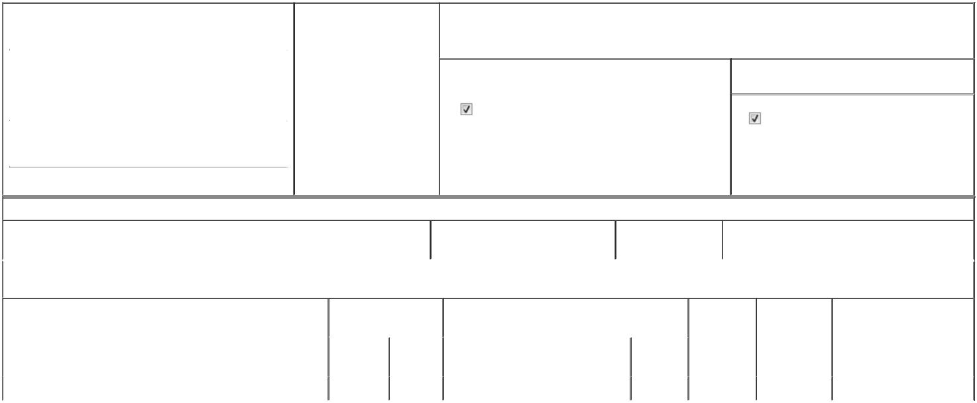

1. Name and Address of Reporting Person* |  |  |  | 2. Date of Event Requiring
 |  | McGarry Kimberly J |  | Statement (Month/Day/Year)
 |  | McGarry Kimberly J |  | 08/14/2025

3. Issuer Name and Ticker or Trading Symbol

Zoom Communications, Inc. [ ZM ]

 | (Last) | (First) | (Middle)
 | C/O ZOOM COMMUNICATIONS, INC.
 | 55 ALMADEN BLVD., #600
(Street)
 | SAN JOSE | CA | 95113

- Relationship of Reporting Person(s) to Issuer (Check all applicable)
Director | 10% Owner
Officer (give title | Other (specify below)
below) | Other (specify below)

Chief Accounting Officer

- If Amendment, Date of Original Filed (Month/Day/Year)

- Individual or Joint/Group Filing (Check Applicable Line)

Form filed by One Reporting Person

Form filed by More than One Reporting Person

(City) (State) (Zip)

Table I - Non-Derivative Securities Beneficially Owned

 | 1. Title of Security (Instr. 4) | 2. Amount of Securities Beneficially | 3. Ownership Form: | 4. Nature of Indirect Beneficial Ownership (Instr. 5)
 |  | Owned (Instr. 4) | Direct (D) or Indirect
 |  |  | (I) (Instr. 5)

Table II - Derivative Securities Beneficially Owned

(e.g., puts, calls, warrants, options, convertible securities)

 | 1. Title of Derivative Security (Instr. 4) | 2. Date Exercisable and |  | 3. Title and Amount of Securities Underlying |  | 4. | 5. Ownership | 6. Nature of Indirect Beneficial
 |  | Expiration Date |  | Derivative Security (Instr. 4) |  | Conversion | Form: Direct | Ownership (Instr. 5)
 |  | (Month/Day/Year) |  |  |  | or Exercise | (D) or Indirect
 |  |  |  |  |  | Price of | (I) (Instr. 5)
 |  |  |  |  | Amount or | Price of | (I) (Instr. 5)
 |  |  |  |  | Amount or | Derivative
 |  | Date | Expiration | Title | Number of | Security
 |  | Exercisable | Date | Title | Shares
 | Restricted Stock Units | (1) | (1) | Class A Common Stock | 49,944 | (2) | D
 | Explanation of Responses:

- The reporting person received an award of restricted stock units, 1/4 of which will vest on July 9, 2026 and the remaining units will vest in 12 equal quarterly installments thereafter, subject to the Reporting Person's Continuous Service (as defined in the Issuer's 2019 Equity Incentive Plan) on each such vesting date. The restricted stock units are subject to accelerated vesting in the event of a termination of employment of the Reporting Person under certain circumstances in connection with a change in control of the Issuer.

- Each Restricted Stock Unit represents a contingent right to receive one share of Issuer's Class A Common Stock.

Remarks:

 | /s/ Aparna Bawa, Attorney-in-Fact |  | 08/22/2025
 | ** Signature of Reporting Person |  |  | Date
Reminder: Report on a separate line for each class of securities beneficially owned directly or indirectly.
* If the form is filed by more than one reporting person, see Instruction 5 (b)(v).
** Intentional misstatements or omissions of facts constitute Federal Criminal Violations See 18 U.S.C. 1001 and 15 U.S.C. 78ff(a).
Note: File three copies of this Form, one of which must be manually signed. If space is insufficient, see Instruction 6 for procedure.
Persons who respond to the collection of information contained in this form are not required to respond unless the form displays a currently valid OMB Number.



